Class Activity: 01

Scenario 1: Student Academic Performance Dashboard
Code:
import pandas as pd
import seaborn as sns
import matplotlib.pyplot as plt

df = pd.read_excel("Student Performance.xlsx")

sns.set(style="whitegrid")

plt.figure(figsize=(8,6))
sns.scatterplot(
data=df,
x="Attendance",
y="Internal Marks",
hue="Department",
palette="Set2",
s=100
)

plt.title("Student Attendance vs Internal Marks by Department")
plt.xlabel("Attendance (%)")
plt.ylabel("Internal Marks")
plt.legend(title="Department")

plt.show()

Output:
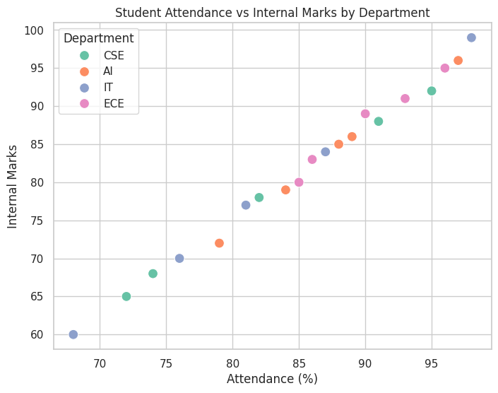

Scenario 2: Electric Vehicle Market Analysis
Code:
import pandas as pd
import seaborn as sns
import matplotlib.pyplot as plt

df = pd.read_excel("Electric Vehicle Market.xlsx")

plt.figure(figsize=(8,6))

sns.scatterplot(data=df,
x="Battery Capacity",
y="Price",
size="Driving Range",
hue="Manufacturer",
sizes=(100,500))

plt.title("Battery Capacity vs Price")
plt.show()

Output:
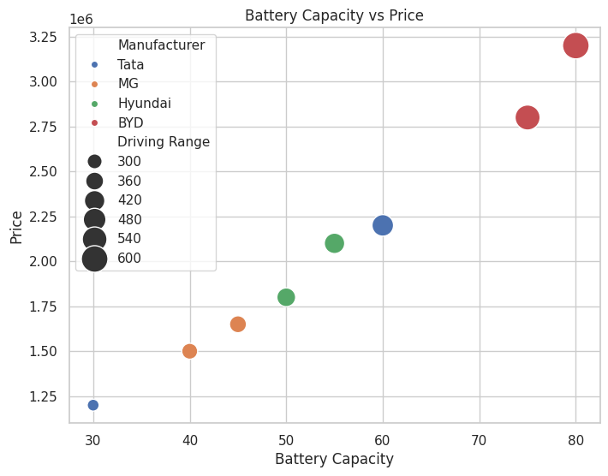
Scenario 3: Hospital Patient Admission Analysis
Code:
import pandas as pd
import matplotlib.pyplot as plt

df = pd.read_excel("Patient Admission.xlsx")

plt.figure(figsize=(8,6))

bars = plt.bar(df["Department"],
df["Number of Patients"],
color=["red","blue","green","orange","purple"])

for bar,cost in zip(bars,df["Average Treatment Cost"]):
plt.text(bar.get_x()+bar.get_width()/2,
bar.get_height()+2,
f"₹{cost}",
ha="center")

plt.title("Hospital Patient Admissions")
plt.xlabel("Department")
plt.ylabel("Patients")
plt.show()

Output:
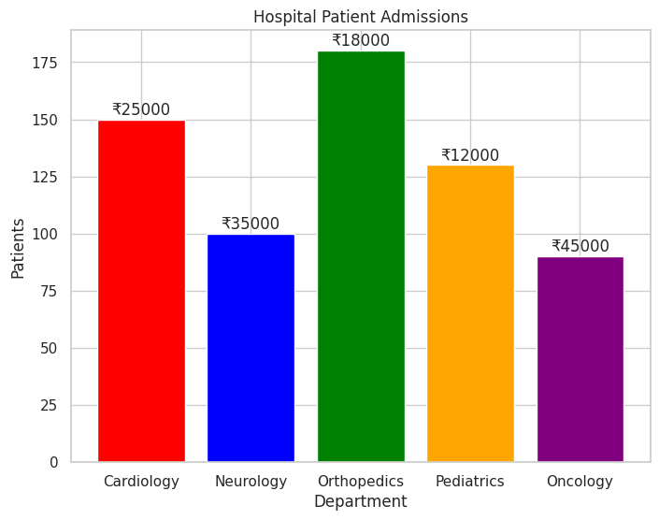
Scenario 4: Weather Monitoring System
Code:
import pandas as pd
import seaborn as sns
import matplotlib.pyplot as plt

df = pd.read_excel("Weather.xlsx")

plt.figure(figsize=(8,6))

sns.lineplot(data=df,
x="Date",
y="Temperature",
hue="City",
style="City",
linewidth=3)

plt.title("Temperature Trends")
plt.show()

Output:
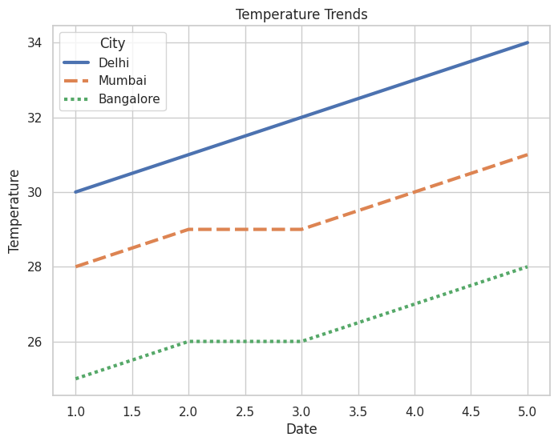

Scenario 5: Supermarket Sales Analysis
Code:
import pandas as pd
import seaborn as sns
import matplotlib.pyplot as plt

df = pd.read_excel("SuperMarketSales.xlsx")

plt.figure(figsize=(8,6))

sns.barplot(data=df,
x="Product Category",
y="Sales Amount",
hue="Branch")

plt.title("Product Sales by Branch")
plt.show()

Output:
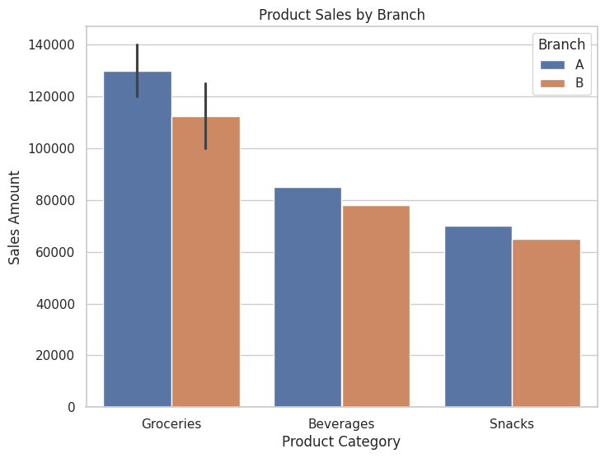

Scenario 6: Employee Salary Distribution
Code:
import pandas as pd
import matplotlib.pyplot as plt

df = pd.read_excel("EmployeeSalary.xlsx")

plt.figure(figsize=(8,6))

plt.hist(df["Salary"],
bins=5,
color="skyblue",
edgecolor="black")

plt.title("Salary Distribution")
plt.xlabel("Salary")
plt.ylabel("Employees")

plt.show()

Output:
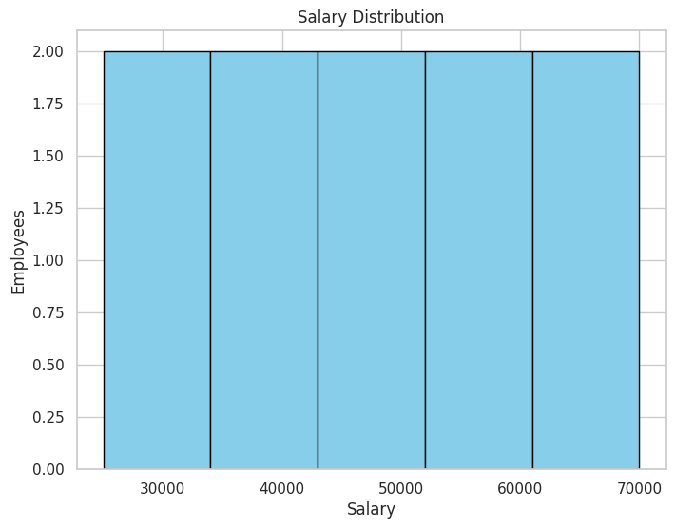
Scenario 7: Smartphone Market Comparison
Code:
import pandas as pd
import seaborn as sns
import matplotlib.pyplot as plt

df = pd.read_excel("SmartphoneMaarket.xlsx")

plt.figure(figsize=(8,6))

sns.scatterplot(data=df,
x="RAM",
y="Price",
hue="Processor Speed",
style="Brand",
size="Storage",
sizes=(100,500))

plt.title("Smartphone Comparison")
plt.show()

Output:
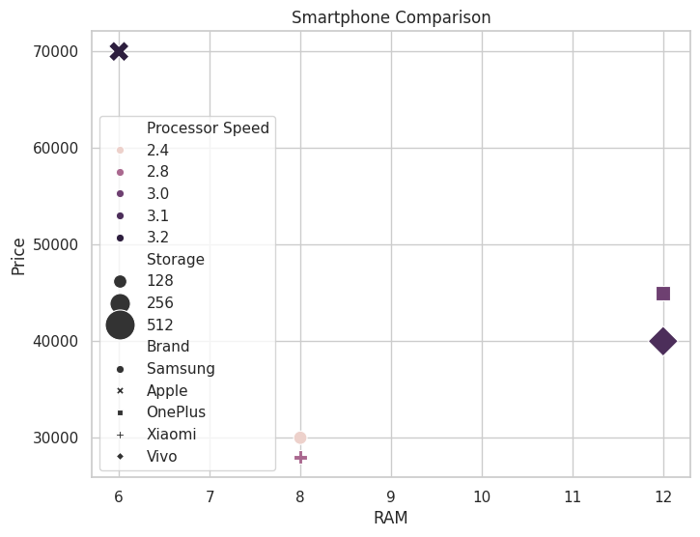
Scenario 8: Online Movie Rating Analysis
Code:
import pandas as pd
import seaborn as sns
import matplotlib.pyplot as plt

df = pd.read_excel("OnlineMovie.xlsx")

pivot = df.pivot(index="Genre",
columns="Release Year",
values="Average Rating")

sns.heatmap(pivot,
annot=True,
cmap="YlGnBu")

plt.title("Movie Ratings Heatmap")
plt.show()

Output:
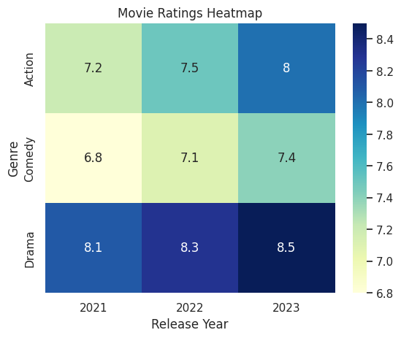

Scenario 9: COVID-19 State-wise Analysis
Code:
import pandas as pd
import seaborn as sns
import matplotlib.pyplot as plt

df = pd.read_excel("Covid-19.xlsx")

data = df.set_index("State")

sns.heatmap(data,
annot=True,
cmap="Reds")

plt.title("COVID Active Cases")
plt.show()

Output:
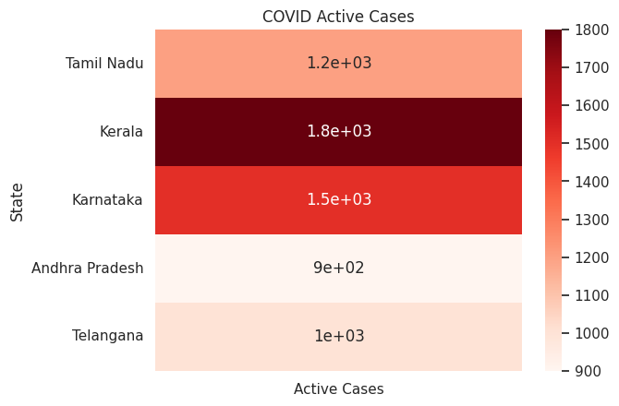

Scenario 10: Iris Flower Classification
Code:
import seaborn as sns
import matplotlib.pyplot as plt

iris = sns.load_dataset("iris")

plt.figure(figsize=(8,6))

sns.scatterplot(data=iris,
x="sepal_length",
y="petal_length",
hue="species",
style="species",
size="sepal_width",
sizes=(50,300))

plt.title("Iris Flower Classification")

plt.show()

Output:
